Searching for Dolly – It ain't Rocket Science.

Inspired by the (very extended) searching for Cindy in the James May's Toy Stories on TV over Christmas 2014, I decided to see how effective the RFM98 LoRa device was at tracking a doll.

The tests were conducted in and around the grounds of Walcot Hall in Shropshire where I happened to be staying over Christmas.
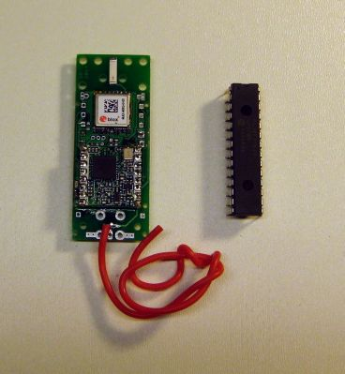

The tracker was my HABAXE2 LoRa based tracker which sends out a full UKHAS compatible payload using LoRa telemetry at BW41.7Khz, SF8 and coding rate 4:5 (1042bps) plus a reduced payload of Latitude, Longitude and Altitude at 41.7Khz, SF12 and CR 4:5 (98bps).

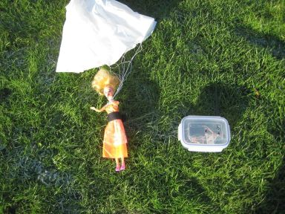

The first LoRa receiver I built was PICAXE and RFM98 based built into a suitable durable hi-tech case, a clip top food container costing £1. This receiver displays the Latitude, Longitude and altitude of the position last recorded by the trackers GPS on the LCD display. This portable receiver can also send out NMEA sentences to its serial port so you can track the location of the remote tracker on a PC Map application, see picture of Dolly with tracker attached and the receiver on the right.

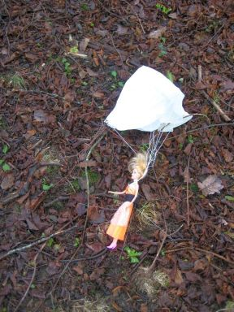

Walcot Hall has an arboretum, a fairly dense bit of woodland around 300M diameter. If Dolly came to ground in this woodland from how far away would the LoRa telemetry (i.e. Dolly's location) be received? The doll with the tracker attached was placed on the ground at the top end of the wood;

I then walked to the location at the bottom corner of the wood shown by the route 1 on the map;

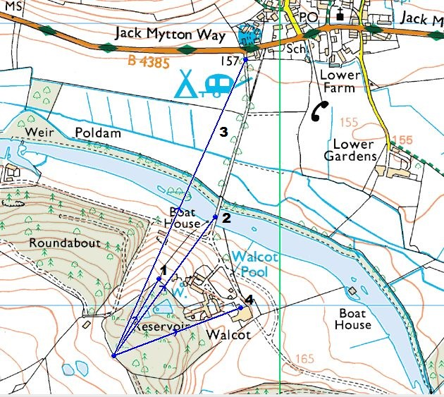

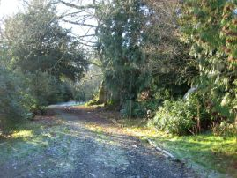
This was 311M away from Dolly. The 1042bps was being received at RSSI -87dBm, +9dBSNR. These are very strong signals, the limit of reception is in the region of -10dBSNR. The tracker is 300M away on the ground in the direction shown in the picture on the right.

This was with the portable receiver’s small vertical antenna fitted. There was, even at this distance a signal margin of around 19dBm! In fact I could still receive the telemetry with the antenna removed from the portable receiver.

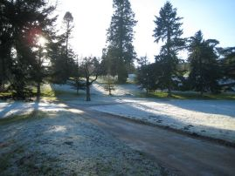

I walked further away towards the Boat House, towards the main road and onto the bridge, route 2 on the map. This was 610M away from Dolly. The 1042bps was being received at RSSI -98dBm and 0dB SNR. The view back to the tracker was the picture on the left;

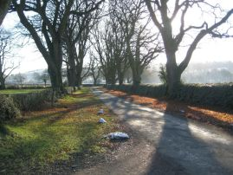

I walked even further away towards the main road, route 3, a distance of 1.15kM from Dolly.
This is the view back to the tracker.
The 1042bps was being received at RSSI -93dBm, +4dBSNR.

Note that at 1.15km, there was still some 14dB of signal margin at 1042bps. Since the 97bps LoRa will operate with a SNR that is 10dB lower, then the receive margin for that rate would be 24dB. Then of course a simple yagi would be expected to provide a further 5 to 10dB of extra signal gain.

At this location I was able to get a direction fix within around 10 degrees on the tracker by aiming the yagi for minimum SNR value or maximum RSSI.

The Dolly tracker also puts out a sequence of tones that rise in frequency but descend in power, thus as you get further away you don’t hear the higher frequency tones. Using the body fade technique for direction finding it was also possible to get a good direction fix on Dolly using a Baofeng hand-held UHF transceiver.

Stuart Robinson
Christmas 2014

